The upgrades to this home are:

- House is approximately 2200 sq. ft.
- Extra heavy (3500 pound) concrete slab. Traditional residential slab is 2500 pound concrete.
- All brick (4-sided) construction.
- Tile floors throughout the home.
- Icynene (foam) insulation throughout the entire home.
- Copper (anti-bacterial) water tubing used. No plastic water pipes.
- "Home Run" hot water system. (instant recirculating hot water like in hotels)
- 17KVA Backup Generator. (supplies power for ½ house needs)
- Dual heating:
  - Traditional HVAC heating and air conditioning,
  - Hydronic (primary) heating coils in the slab floor.
- Four additional Mitsubishi (Mr. Slim) room air conditioners as backup/supplemental AC.
- "Mechanical Room" is built on side of house with separate entrance for maintenance persons and ease of maintenance of systems which include:
  - Dual water filters (sediment, and chemical)
  - Traditional water heater for home.
  - Water heater for hydronic floor heat.
  - Extra (Pure-Aire) air filtration system and HRV (Heat recovery ventilator).
  - Phone and network drops throughout home, terminate in the mechanical room.
- The home is designed to be wheelchair accessible.
  - Low thresholds, wide doors, wide hallway, wheelchair accessible sinks, grab bars.
  - Rocker light switches.
  - Baseboard receptacles "raised" to eliminate need to bend down to plug in appliances.
  - Doors are wide for wheel chair access.
  - Wide hallway and wheel chair turn area at end of hallway (master and second bedroom).
- Master bathroom is wheelchair compatible.
  - One of the sinks designed to allow wheelchair access.
  - Grab bars are available in tub, and toilet area
- Half bath has wheel chair accessible sink, and grab bars for toilet.
- All three entrances have "mud" rooms. Isolated from main house ventilation.
- Bedroom #3 is isolated from the home in that it has its own separate entrance, isolated from house, to allow for home office access without disruption to occupants. Excellent room for a teenager.
- "Laundry Room", actually large enough to be a bedroom or home office, is plumbed for two washers and electric dryers.
- Two dish washers. (one draw type, the 2nd is a smaller traditional dish washer)
- All casework (wood work, door frames, moldings) are solid maple.
- All inside doors are solid maple or oak wood.
- All cabinets have solid maple slab doors, and pure-bond (formaldehyde free) plywood.
- Elfa closet shelving throughout.
- Extra-large garage. Can fit a full sized 4 door pickup truck with room to open the doors.
- Screened in porch.
- Work shop (12 X 24') that can be used for hobbies. Heated and AC.
- Garden shed (8 X 12').
- Gutter guard type, maintenance free gutters.
- Zoysia grass, and in-ground sprinkler system.

The hydronic coils, and 2" of Styrofoam that is under the entire slab. The concrete in the slab is upgraded from the usual 2500 pound rating to a 3500 pound rating.

This minimizes the cold temperatures from the earth from migrating thru the concrete. Also keeps the heat from the hydronic coils from going to the earth, and helps heat the room.

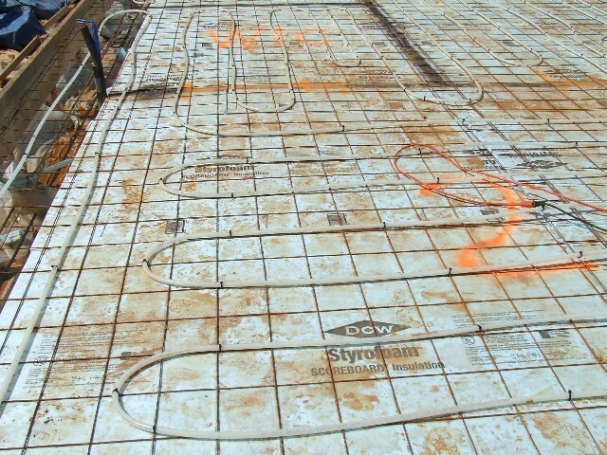

The Icynene insulation in the walls of the house, and sample attic view. Like living in a styrofoam cup.

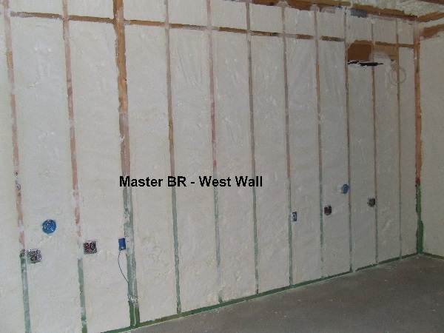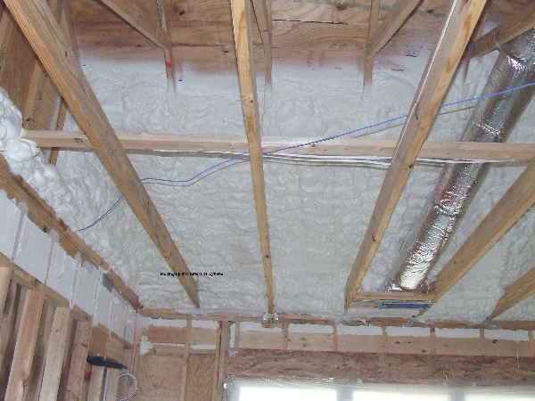

The tile floor, with an infrared view of the hydronic heating coils

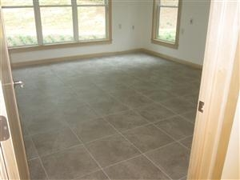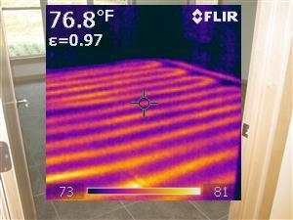

==================================================
The kitchen, with the far end showing the lower wheel chair accessible station.

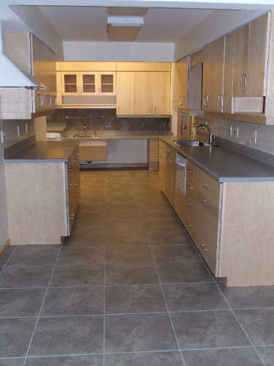

The master bath with the wheel chair accessible 2nd sink area. Grab rails throughout the bathroom. The half bath showing the grab rails, and wheelchair accessible sink.

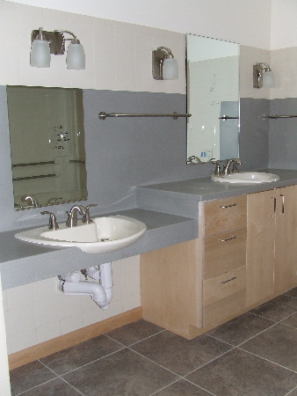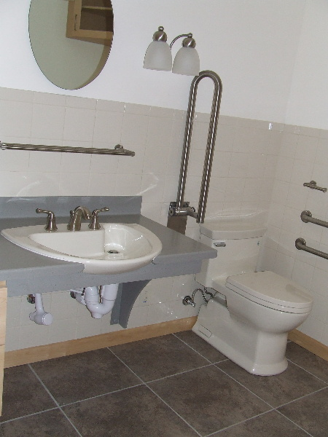

=============================================
The Icynene exhibits excellent insulation, as can be seen during a frost of the roof.

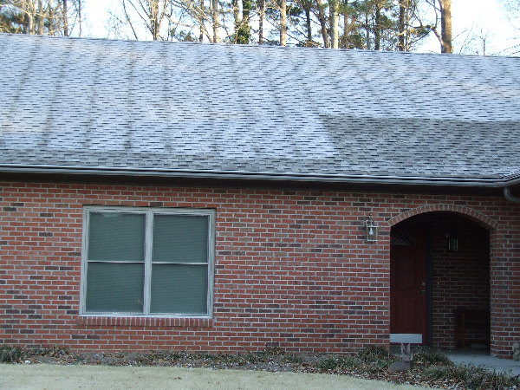

The "mechanical room" built on the side of the house, houses all the water heaters, water filters, HVAC units and air filtration. So that no maintenance is necessary in the attic. A separate entrance to this room enables maintenance personnel to work there without disturbing residents.

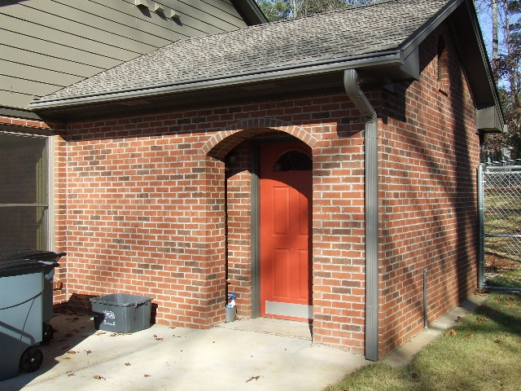

===========================
Moldings/casework is all solid maple. This is a 4-door car with plenty of leg room.
Excuse the tilt in the photo The garage also holds a full size 4 door pickup.

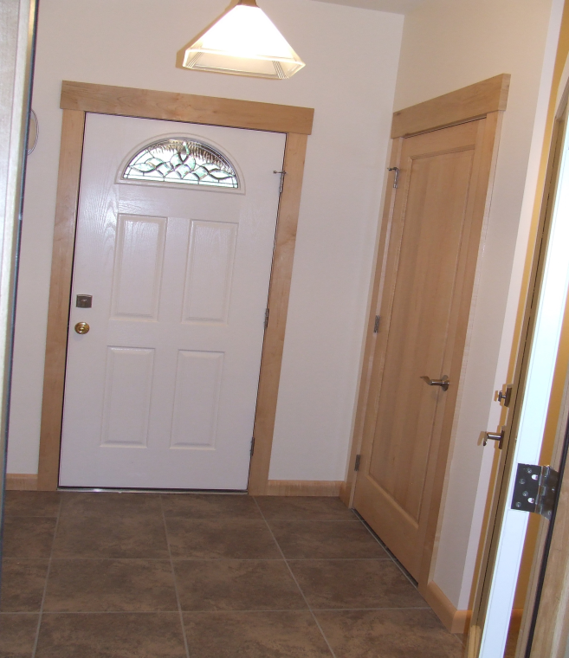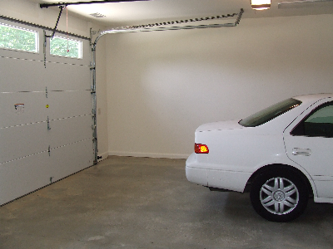

Master Tub (fibreglass) with grab bars
